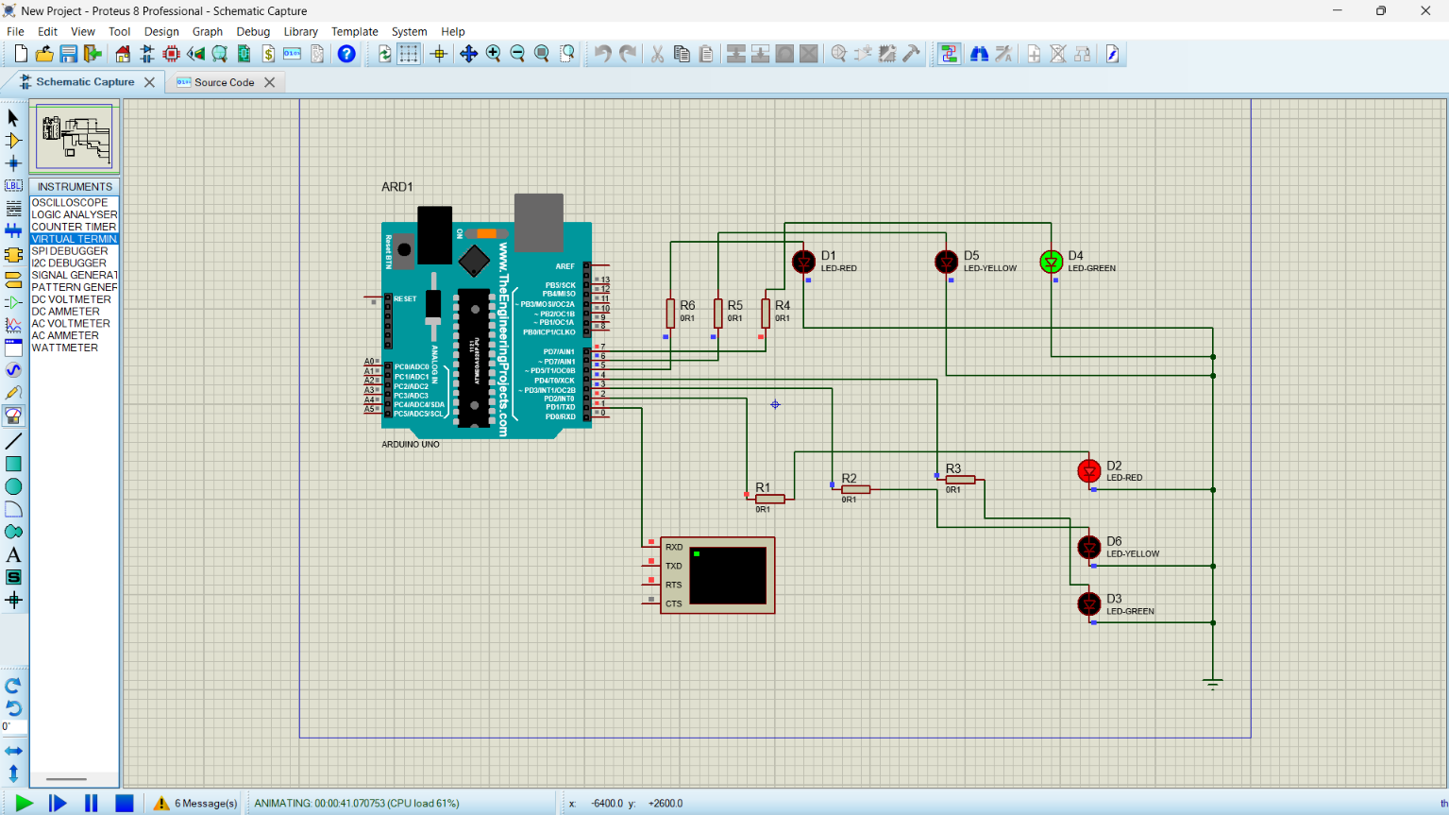/*
Formal Design of Embedded Controller Using FSM
Traffic Light Controller
Arduino UNO + Proteus
*/
enum TrafficState {
STATE_NS_GREEN,
STATE_NS_YELLOW,
STATE_EW_GREEN,
STATE_EW_YELLOW
};
TrafficState currentState = STATE_NS_GREEN;
// North-South traffic signal pins
const int NS_RED_PIN = 2;
const int NS_YELLOW_PIN = 3;
const int NS_GREEN_PIN = 4;
// East-West traffic signal pins
const int EW_RED_PIN = 5;
const int EW_YELLOW_PIN = 6;
const int EW_GREEN_PIN = 7;
void allOff() {
digitalWrite(NS_RED_PIN, LOW);
digitalWrite(NS_YELLOW_PIN, LOW);
digitalWrite(NS_GREEN_PIN, LOW);
digitalWrite(EW_RED_PIN, LOW);
digitalWrite(EW_YELLOW_PIN, LOW);
digitalWrite(EW_GREEN_PIN, LOW);
}
void enterState(TrafficState state) {
allOff();
switch (state) {
case STATE_NS_GREEN:
digitalWrite(NS_GREEN_PIN, HIGH);
digitalWrite(EW_RED_PIN, HIGH);
Serial.println("S0: NS GREEN - EW RED");
break;
case STATE_NS_YELLOW:
digitalWrite(NS_YELLOW_PIN, HIGH);
digitalWrite(EW_RED_PIN, HIGH);
Serial.println("S1: NS YELLOW - EW RED");
break;
case STATE_EW_GREEN:
digitalWrite(NS_RED_PIN, HIGH);
digitalWrite(EW_GREEN_PIN, HIGH);
Serial.println("S2: NS RED - EW GREEN");
break;
case STATE_EW_YELLOW:
digitalWrite(NS_RED_PIN, HIGH);
digitalWrite(EW_YELLOW_PIN, HIGH);
Serial.println("S3: NS RED - EW YELLOW");
break;
}
}
void setup() {
pinMode(NS_RED_PIN, OUTPUT);
pinMode(NS_YELLOW_PIN, OUTPUT);
pinMode(NS_GREEN_PIN, OUTPUT);
pinMode(EW_RED_PIN, OUTPUT);
pinMode(EW_YELLOW_PIN, OUTPUT);
pinMode(EW_GREEN_PIN, OUTPUT);
Serial.begin(9600);
enterState(currentState);
}
void loop() {
switch (currentState) {
case STATE_NS_GREEN:
delay(10000); // 10 seconds
currentState = STATE_NS_YELLOW;
break;
case STATE_NS_YELLOW:
enterState(STATE_NS_YELLOW);
delay(3000); // 3 seconds
currentState = STATE_EW_GREEN;
break;
case STATE_EW_GREEN:
enterState(STATE_EW_GREEN);
delay(10000); // 10 seconds
currentState = STATE_EW_YELLOW;
break;

case STATE_EW_YELLOW:
enterState(STATE_EW_YELLOW);
delay(3000); // 3 seconds
currentState = STATE_NS_GREEN;
enterState(currentState);
break;
}
}

